Program Design – 15.10.19

* Explanation of arrays. Read last sessions notes.
* Array is a memory block with multiple stored variables all of the same kind, all ints, all chars etc.
* Array Flowchart Diagram:

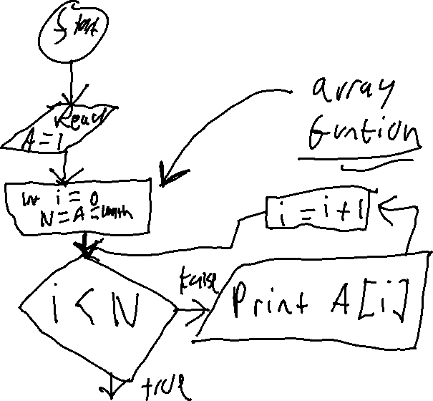

* “Working” use of a array flowchart function.

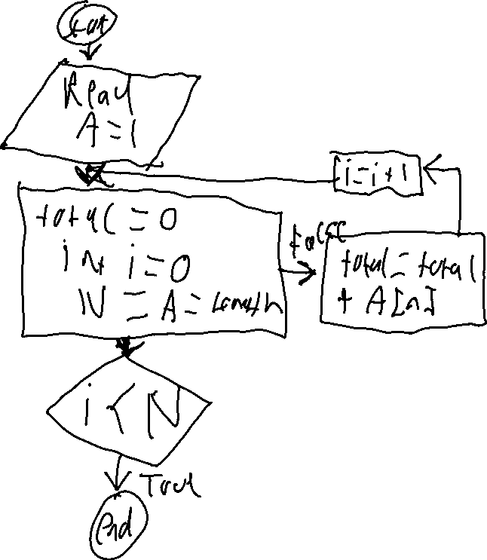

* A[i], i being an index. Meaning it can mean A[1], A[2], A[3] etc.
* “Problem – Reverse the order of the elements of a given array”